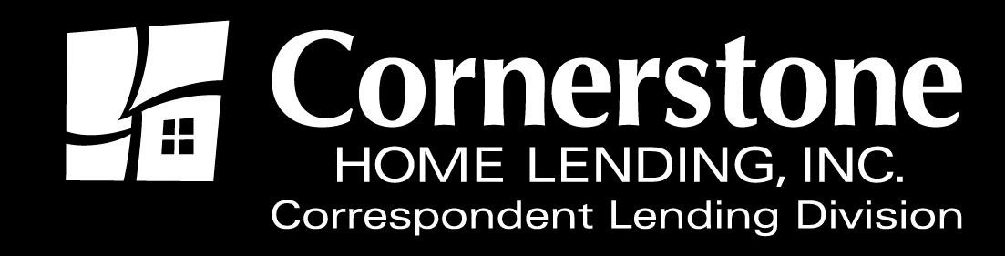

TO: Correspondent Lenders

FROM: Jason Kershaw, CLD Operations Manager

DATE January 3, 2017

RE: R Jumbo Product Update
VA LSAM Requirement

R Jumbo Product Update

The R Jumbo Product Guidelines have been updated. Updates are effective immediately. A revised R-Jumbo Product Program Eligibility Guide and Jumbo Program Eligibility Supplement are attached and will be posted to the correspondent web-site: www.chlcorrespondent.com in the next few days.

VA LSAM Requirement

Effective immediately, a copy of the LSAM (Loan Safe Appraisal Manager) is required with all VA loan submissions.

As always, your business is greatly appreciated. If you have questions regarding these issues, please contact me at JKershaw@houseloan.com .

The content of this communication is confidential and is not intended for consumer use or for distribution to any third party without prior written consent from Cornerstone Home Lending, Inc.

