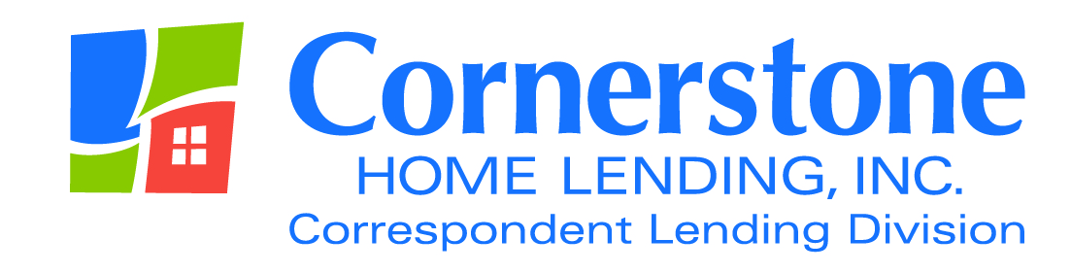

TO: Correspondent Lenders

FROM: Angela Breidenbach, Operations Manager

DATE January 11, 2016

RE: Collateral Underwriting (CU)
Loan Package/Condition Upload Specifications

Collateral Underwriting (CU)

As you are aware, last January, in a continued effort to obtain more consistent appraisal data, FNMA rolled out CU risk scores, flags and messages through the Uniform Collateral Data Portal.

Additionally, in April of 2015, FNMA made available the Collateral Underwriter (CU) web-based user interface to non-seller correspondent lenders. This CU Complete Report provides a “deeper dive” than the data available on the UCDP report and includes comparable sales data, market trends, mapping, aerial photography, public records and other functionality which makes it possible to perform a much more in-depth analysis of an appraisal.

Why the reminder?

It is important to remember that a risk score rating of 1, 2 or 3 does not necessarily mean that additional inquiry, on behalf of the underwriter, is not warranted. In many cases, a deeper look at these findings is warranted and advisable, and Cornerstone is beginning to receive audit feedback from FNMA regarding some of these lower risk factor ratings.

Therefore, the following requirements will become effective as of February 1, 2016:

DELEGATED LOANS

- Will require a copy of the CU Complete Report in every conventional conforming loan file; regardless of risk score. You should be able to pull a copy of this report along with your UCDP report. If this is not currently an option for you, please contact your software vendor for assistance.

- We will continue to require a written statement from the underwriter, for risk scores of 4 or above, regarding how these specific messages were addressed.

- Additionally, it is strongly advisable that your underwriter review this report and provide comments to the file as necessary. We are providing a copy of the CU Job Aid that we use internally as a guide for reviewing the CU Complete Report. Although this aid is not exhaustive, it should be helpful in determining what, if any, additional steps need to be taken. A copy of this form will be available under the Checklist section of the Forms page on the correspondent website: www.chlcorrespondent.com.

NON DELEGATED LOANS/JUMBO LOANS

- Will require a copy of the CU Complete Report in every conventional conforming loan file; regardless of risk score. You should be able to pull a copy of this report along with your UCDP report. If this is not currently an option for you, please contact your software vendor for assistance.

- Later on this year, lenders will have the option of assigning CU Complete Reports to investors. Once this is available, we will require that you assign these reports to us at the time of underwriting submission. Stay tuned for additional information as it becomes available.

Loan Package/Condition Upload Specifications

As a reminder, when uploading loan packages and conditions, please make sure you are using the correct options as follows:

DELEGATED LENDER

To submit a purchase file, click on the Loan Package button and select the PURCHASE FILE (delegated submission for purchase review) option.

To submit Conditions, please click on the Loan Condition button and select the CLD option. Note: it is extremely helpful if you send one condition per browse file.

NON-DELEGATED LENDER/PRODUCT

To submit the underwriting file, click on the Loan Package button and select UW SUBMISSION (non-delegated files to be underwritten)

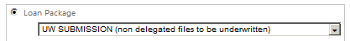

To submit underwriting conditions, click on Loan Condition button and select UNDERWRITING option

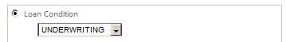

Once you have received a Clear to Purchase and are ready to send the closing package, click the Loan Package button and select the CLOSING FILE (closing package for non-delegated approved/closed file) option.

To submit Purchase Conditions (CLD), please click on the Loan Condition button and select the CLD option. Note: it is extremely helpful if you send one condition per browse file.

As always, your business is greatly appreciated. If you have questions regarding these issues, please contact me at abreidenbach@houseloan.com.

The content of this communication is confidential and is not intended for consumer use or for distribution to any third party without prior written consent from Cornerstone Home Lending, Inc.

