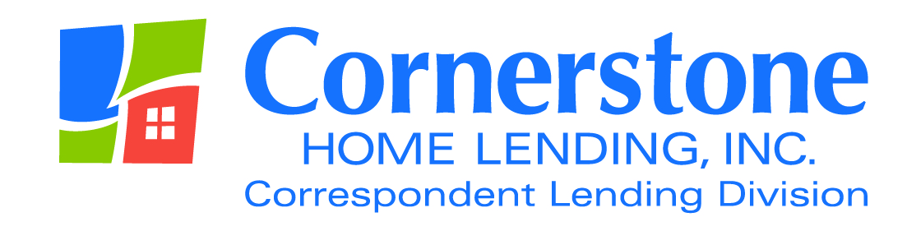

TO: Correspondent Lenders

FROM: Angela Breidenbach, Operations Manager

DATE January 25, 2016

RE: 5 Day Lock Expiration Notification

VERY IMPORTANT

Beginning Monday, February 1st, 2016, Cornerstone will no longer send out daily notifications on lock expirations.

Instead, you will receive a notification on the first day of the business week (usually Monday) notifying you of all loans due to expire that week.

Please take the time to read the email and respond directly to the CLD Lock Desk cornerstonecld@houseloan.com on ALL extension, relock and cancellation requests.

If no response is received on an expired lock, it will automatically be cancelled 3 business days after expiration.

As always, your business is greatly appreciated. If you have questions regarding these issues, please contact me at abreidenbach@houseloan.com.

The content of this communication is confidential and is not intended for consumer use or for distribution to any third party without prior written consent from Cornerstone Home Lending, Inc.

