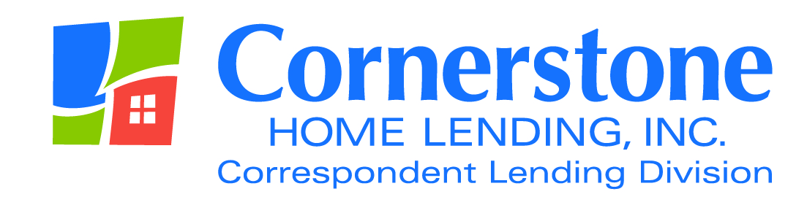

TO: Correspondent Lenders

FROM: Angela Breidenbach, Operations Manager

DATE February 2, 2016

RE: New Mexico Clear to Close

In July of 2015, Cornerstone Correspondent Lending underwent an examination for compliance of all applicable state laws. During this examination it was determined that loans purchased from lenders originated on New Mexico properties were lacking language showing notification to the borrower(s) that they were clear to close as per NM statue 12.19.8.8:

12.19.8.8 APPLICANT AND LICENSEE REQUIREMENTS:
A. Application for licensure: In addition to the information required by Section 58-21-4 NMSA 1978 of the act, each applicant for issuance or renewal of a license shall be subject to the following requirements:

C. Licensees shall keep the following records and make them available upon examination or investigation:
(1) documents related to the withdrawal, denial or settlement of a residential mortgage loan which includes, but are not limited to:
- mortgage loan transaction documents: all loan applications, written or electronic, mortgage loan settlement statement, loan transmittal summary, credit report, appraisal, all verifications (mortgage, rent,
deposits, employment, income), lender loan approval, clear to close and interest rate lock-in confirmation, title commitment, survey and sales contract (if loan is a purchase);

This examination further revealed that even though small banks and credit unions are exempt from this statute under the Mortgage Loan Company Act (MLC), once a company that is licensed under the MLC Act purchases/ acquires loans, they become subject to that Act. Therefore, because Cornerstone is not a bank, we are subject to MLC requirements.

During the course of implementing this regulation, we were able to verify that the clear to close language may be implemented on the 1008, FHA Underwriting Transmittal or VA Loan Analysis accordingly; as long as the following three elements are provided.

- The underwriter’s name
- The date that the underwriter cleared the loan to close
- The statement “cleared to close” is used

For example: Cleared to Close on 1/26/16 by Paula Christopher

As an alternative, you may also use the Clear to Close form located in the Submission Forms section of the Checklists, Forms and Tools page of the correspondent web site: www.chlcorrespondent.com.

Please let me know if you have questions.

As always, your business is greatly appreciated. If you have questions regarding these issues, please contact me at abreidenbach@houseloan.com.

The content of this communication is confidential and is not intended for consumer use or for distribution to any third party without prior written consent from Cornerstone Home Lending, Inc.

