TO: Correspondent Lenders

FROM: Angela Breidenbach, Operations Manager

DATE December 30, 2015

RE: Early TRID Issues

In an effort to continue to provide guidance to our correspondent lenders, the following information is a summary of issues that have been identified during purchase reviews on loans delivered to Cornerstone. Please check your loans thoroughly prior to delivery to ensure a seamless purchase process:

GENERAL ISSUES

- The earliest that consummation can occur (generally the date the mortgage is signed) is three business days after the borrower has received the initial CD or a subsequent CD that requires a new waiting period.

- If multiple CD’s are issued on the same day, please provide documentation to show in what order they were issued.

- If an LE or CD was printed, but not delivered to a borrower, please don’t include it in the file to be delivered to Cornerstone.

- All CD’s issued to the borrower must have supporting documentation to evidence delivery and receipt of disclosures (unless mail box rule is employed).

- If the disclosures are sent out electronically, Cornerstone requires evidence of borrower’s e-sign consent to ensure compliance with the regulation.

- If the borrower was allowed to shop for services, please be sure you have included the Service Providers List.

- On refinances and other transactions not involving a seller, the lender has the option to use an alternative form LE and CD. The regulation is clear that if you use the alternative form LE, you must also use the alternative form CD. However, the regulation is not clear on the requirement when the LE is completed on the standard form. At the present time, Cornerstone is taking the position that there should be consistent use of the LE and CD forms. If the LE was completed on the standard LE form, then the CD should also be completed on the standard CD form. WE are seeing loans where a standard form LE is used with an alternative form CD. The calculating cash to close table do not properly align when this occurs.

LOAN ESTIMATES (LE)

- The rate lock information must include a time stamp.
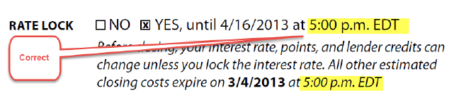

- On page 3 Additional Information About This Loan, make sure all of the required information is provided.
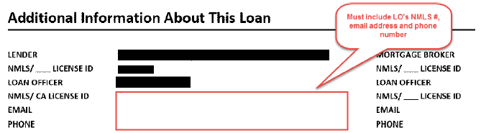

- Provide Change of Circumstance for all re-disclosed LE’s.

CLOSING DISCLOSURES (CD)

- All relevant fields in the Closing Information section (page 1) must be completed. This applies to all CD’s: initial, re-disclosed and final
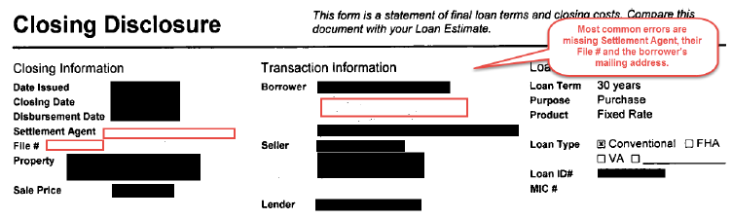

- CD page 3 Calculating Cash to Close estimate should match the final LE.

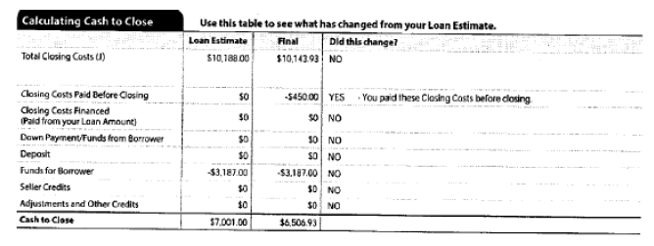
- Ensure that all applicable check boxes are marked on Page 4 of the CD Additional Information About this loan. Also, be sure that, in the case of waived escrows, the reason box is also checked.
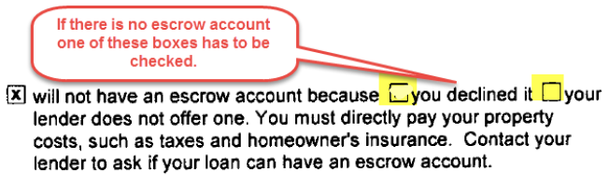
- Escrowed Property Cost of Year 1 on page 4 should typically be equal to the “Monthly Escrow Payment” multiplied by 11 months (this is the number of scheduled payments in the first year after consummation).
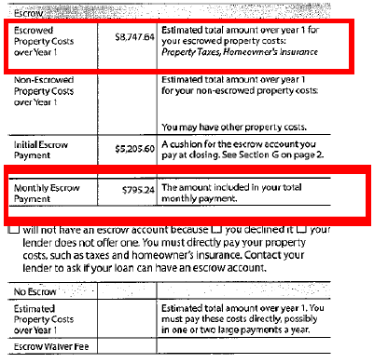
- Ensure that all applicable check boxes are marked on Page 5 of the Other Disclosures section regarding Liability after Foreclosure.

- Ensure that all applicable fields and columns are completed on Page 5 Contact Information section.
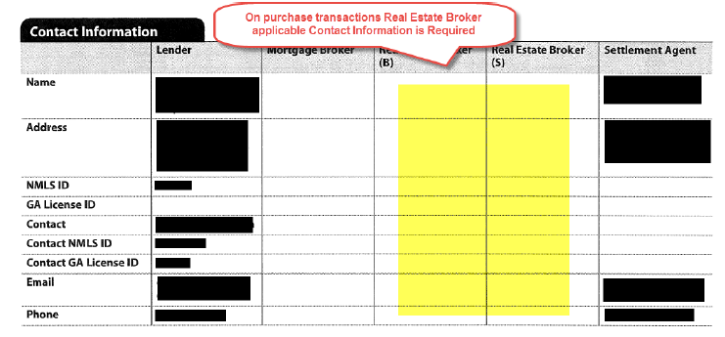

JUMBO LOAN ESTIMATES (LE) – This is in addition to the LE section above

- If there are no Lender Credit given to the borrower, then page1 Cost at Closing should be populated with $0 disclosed for lender credits (field should not be left blank). However, on page 2 of LE Section J, Lender Credits should be left blank when a Lender Credit is not given.
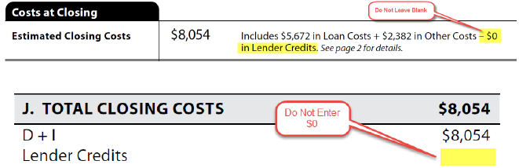

- In section # of the LE, Recording Fees and Transfer Taxes are disclosed. If the borrower does not pay for the Transfer Tax, then the amount field should be blank. Do not enter $0.
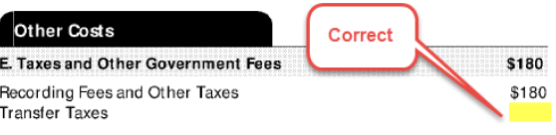
As always, your business is greatly appreciated. If you have questions regarding these issues, please contact me at abreidenbach@houseloan.com.

